Part 7 (30 points):
Answer the following queries, using only the tables shown in the figure and provided within the corresponding sql script.
You are also provided with a script to drop all your current tables and create only the ones you need:
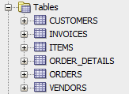
You should provide both the query that you use and the results of the query. You can simply copy the answer of the query and paste at the designated space.
Part 7: (File Upload) (30 points)
- Report the ids of the customers whose first name starts with K and who live in OH. Order the results by the customer last name.
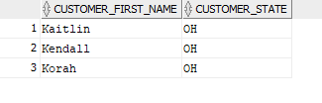
select customer_first_name, customer_state
from customers
where customer_first_name LIKE 'K%' AND customer_state LIKE 'OH'
order by customer_first_name;
- Report the artist and the average price of items per artist, for the artists who are alphabetically before ‘Onn’. Report the results in alphabetical order.
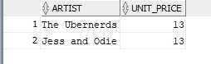
SELECT artist, unit_price
FROM items
WHERE unit_price =
(SELECT MIN(unit_price) FROM items);
- Find the order_ID for all the orders that include both items with item_id = 1 and item_id = 4; Order by the order Id.

- Report the name of the item and the number of times it has been included in an order, for the items with id smaller than 5 and larger than 1. Order by the order id.

- Find the name of ALL the vendors, the city of the vendor and the total invoice amounts (Invoice_total) per vendor. Restrict your results to the vendors whose city starts with A. If a vendor has no invoices then report 0. Report the results in alphabetical order.

- Find the vendor contact first names (from table vendors) that exist more than once. Report the results in alphabetical order.
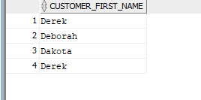
SELECT vendor_contact_first_name,
COUNT(vendor_contact_first_name) AS NumOccurrences
FROM vendors
GROUP BY vendor_contact_first_name
HAVING ( COUNT(vendor_contact_first_name) > 1 );

- Find the last names of ALL the customers whose first name starts with a ‘D’. For all those customers report the sum of their ordered quantities. Report the results in alphabetical order of their last name.
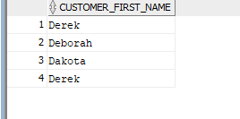
select customer_first_name
from customers
where customer_first_name LIKE 'D%'
order by customer_id;

- Find the ids of the vendors whose aggregated invoice total is equal to their payment total. Report only the 6 smallest vendor ids and order by vendor ids;
Hint: First find the sum of invoice_total and payment_total for each vendor and then restrict your results to find only the needed vendors.

- Find the first name of the customers who have bought items created by Burt Ruggles. Report the first names in descending order of the customer’s last name.

- Find the ids of the vendors who are from WI. Also find the vendors who are from CA and have vendor contact last name that starts with Q. Order by vendor id.
For venders in WI
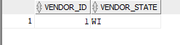
select vendor_id, vendor_state
from vendors
where vendor_state LIKE 'WI'
order by vendor_id;
for venders in CA
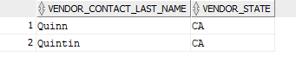
select vendor_contact_last_name, vendor_state
from vendors
where vendor_contact_last_name LIKE 'Q%' AND vendor_state LIKE 'CA'
order by vendor_id;

